**BLOOD DONATION MANAGEMENT SYSTEM**

**WEB PROJECT (1)**

**FWD291**

**Blood donations**

**Supervisor: Dr. Rahma Barnawi**

**Presented by:**

**Reha Ibrahim**

**SID # 4451964**

**Lana Al-Juhani**

**SID #4450984**

**Atheer Al-Harbi.**

**SID #4451855**

Atheer Al-Harbi.

**Abeer Al-Anazi.**

**SID #4453204**

**Tuqaal-Nakhli**

**SID #4553366**

**Academic Year 1445 AH**

# Acknowledgement

The success and results of this project have required a tremendous amount of guidance, and fortunately, we have achieved that throughout our project.

All that we did was, firstly, by the grace of Allah Almighty for His bounty to complete the project, without his blessings, we would not be able to do anything.

Then, we like to express our special thanks and gratitude to our supervisor,

**Dr. Hala Hameed**

, who helped us and directed us throughout the period of work on this project then.

In the end, the support and help from people around us we think it is necessary to thank them, we thank our professors and colleagues who have been supportive of us throughout the project.

# Abstract

The service aims to enable community members to donate blood to give it to those in need.

Each whole blood donation could save three lives. Donated blood also contributes to meeting many medical needs, such as cases of people who have lost amounts of blood due to physical injuries, an organ transplant, or any major surgery, in addition to people who are unable to produce a sufficient amount of blood due to illness or undergoing treatment.

Donating blood helps reduce the level of iron in the blood because no one suffers from heart disease and clogged arteries. Studies have shown that those who donate their blood at least once a year are less likely to suffer from.

# List of Tables

‎**4.4‑1 Table: DONOR** 25

**‎4.4‑2 Table: RECIPIENT** خطأ! الإشارة المرجعية غير معرّفة.

**‎4.4‑3 Table: MANAGEMENT 25**

**‎4.4‑4 Table: LAB_ASSISTANT 26**

**‎4.4‑5 Table: STAFF 26**

**‎4.4‑6 Table: BLOOD 26**

**‎4.4‑7 Table: BLOOD_BANK 26**

**‎4.4‑8 Table: HOSPITAL 27**

**List of Figures**

Figure ‎1‑1 Project Timeline 4

Figure ‎2‑1 Wateen application 7

Figure ‎2‑2 lhsan platform 8

Figure ‎3‑1 Use case Diagram 13

Figure ‎3‑2 Flow Chart 1 14

Figure ‎3‑3 Flow Chart 2 15

Figure ‎3‑4 Flow Chart 3 16

Figure ‎3‑5 Flow Chart 4 16

Figure ‎3‑6 Waterfall Methodology 17

Figure ‎4‑1 Data Flow Diagram - Context Diagram 19

Figure ‎4‑2 -Data Flow Diagram - Level 0 20

Figure 9 Home page user interface design 28

Figure 10 User interface design of LOGIN 29

Figure 11 User interface design of CREATE AN ACCOUNT 30

‎4.2‑1 System Architecture 21

‎4.3‑1 sequence diagram 23

‎4.3‑2 Activity diagram 24

Figures 12 Admin Log In 32

Figures 13 A dmin Donor List 33

Figures 14 Add Donor 33

Figures 15 Admin Manage Page Data 34

Figure 16 admin Update Contact Info 34

Figures 17 User Donate Blood 35

Figures 18 User Need Blood 35

Figures 19 User Why Should I Donate Blood 35

Figures 20 User Contact Us 36

# Table of Content

**Table of Contents**

Acknowledgement ii

Abstract iii

List of Tables iv

List of Figures v

Table of Content vii

1 Chapter 1: Introduction 1

**1.1 Introduction 1**

**1.2 Problem Definition 1**

**1.3 Project Objectives 2**

**1.4 Project Scope 3**

**1.5 Project Timeline 3**

**1.6 Document Organization 5**

2 Chapter 2: Literature Review 7

**2.1 Introduction 7**

**2.2 Related work and Similar Systems 7**

**2.3 Summary 9**

3 Chapter 3: Project Requirements and System Analysis 10

**3.1 Introduction 10**

**3.2 Requirements 10**

**3.2.1 Functional Requirements 10**

**3.2.2 Non-Functional Requirements 11**

**3.3 System Design 11**

**3.3.1 Use Case Diagram 11**

**3.3.2 Flow Chart 14**

**3.4 Development Methodology 17**

**3.5 Summary 18**

4 Chapter 4: System Design 19

**4.1 Introduction 19**

**4.2 Architectural design 21**

**4.3 Object Oriented Design 22**

**4.3.1 Class Diagram 22**

**4.3.2 Sequence Diagram 23**

**4.3.3 Activity Diagram 24**

**4.4 Database Design 24**

**4.5 User Interface Design 27**

**4.5.1 Home page user interface design 27**

**4.6 Summary 30**

5 Chapter 5: Implementation and Results 31

**5.1 Introduction 31**

**5.2 Tools and Technologies used 31**

**5.3 Implementation 31**

**5.4 Testing Case 32**

**5.5 Results 32**

6 Chapter 6: Conclusion and Future Work 37

**6.1 Conclusion 37**

**6.2 Limitations 37**

**6.3 Future Work 37**

References 38

# Chapter 1: Introduction

## Introduction

Blood donation: A simple medical procedure contributes to saving lives. So a person donates his blood voluntarily, and the blood is taken from a healthy person and preserved, then preserved so that it can be used to treat another person’s conditions in emergencies that require a blood transfusion, or for people who are potential patients for long-term.

## Problem Definition

Millions of people need blood transfusions annually. Some may need blood while undergoing surgery. Others rely on it after being in an accident or suffering from a disease that requires obtaining some blood components. Donating blood allows for all of this. There is no substitute for human blood. Therefore, all blood transfusions use blood from donors.

**What are the reasons for blood transfusion?**

A blood transfusion is necessary if you lose blood due to bleeding, serious injury, or during surgery. But some people may need blood transfusions to treat certain conditions and disorders, including:

Anemia Blood transfusion Anemia is one of the most prominent causes of blood transfusion, and it occurs when a person's blood does not contain a sufficient amount of red blood cells.

Hemophilia is a bleeding disorder in which the blood is unable to clot.

* Cancer.

* Sickle cell disease is a group of red blood cell disorders that change their shape.

* Kidney disease.

* Liver diseases.

**Problems accessing donors**

1-With an increase in the need for blood donors, hospitals are facing a lot of difficulties in finding them.

2-‏the lack of awareness in society about the necessity of donating

3-Lack of link between donor and recipient in

Case of emergency

4-If the patient needs an emergency operation, do not wait for a donor to arrive

5-Lack of rare blood types.

## Project Objectives

This project will contribute to solving the problem of blood shortage and will have a significant positive impact on society .

As we are the students behind our project, our objectives are focused and deliberate, aimed at directly confronting the challenge of blood shortages. Our goals are:

1. To enhance the visibility of blood supplies, making it easier to track and manage available stocks in real-time across hospitals and blood banks.

2. To increase donor engagement by simplifying the donation process with a user-friendly interface and notifications for when urgent blood donations are needed.

3. To facilitate efficient matching between donors and recipients, ensuring those in need receive blood in a timely manner.

4. To raise community awareness about the importance of donating blood, fostering a culture of regular donation through educational campaigns.

5. To ensure the security and privacy of all our users' data, adhering to the highest standards of data protection.

6. To continuously adapt and respond to our region's needs, evaluating the effectiveness of our application and making necessary adjustments.

By achieving these goals, we aim to make a significant, positive impact on our society, addressing the urgent issue of blood shortages and enhancing community health and wellbeing.

## Project Scope

The scope of our blood donation management system project is to develop a web-based platform that allows efficient management of blood donation activities between donors, recipients, and administrators.

**The key in-scope elements include:**

- Donor and recipient registration and profiles

- Search and matching of donors to recipients

- Appointment booking for donations

- Donation history and inventory management

- Admin dashboard for management and reporting

Out of scope are elements such as integration with external hospital systems, complex

Medical records or testing data, mobile applications, advanced analytics and business

Intelligence. The initial release will focus on core donation functionality for a single

Organization. Additional features may be considered in future enhancements based on Requirements.

The project aims to provide a basic but full-functioning system within the defined

Boundaries. Feedback from initial users will help evaluate expanding scope as needed. Regular Scope reviews will maintain focus on key objectives and deliverables.

## Project Timeline

This section outlines the d timeline for our web-based blood donation platform project.

As the student development team, we expect to complete the project within 6 months

According to the following timeline:

* The first involve concluding our background research and finalizing system requirements based on user needs analysis. By the end of this phase, we aim to have our project proposal and design documents ready for review.
* In the second month, we will focus on developing the core application architecture and building out the front-end interface. Basic functionality for user registration and profile management is targeted for completion.
* By the third month, more complexd inventory management and appointment scheduling are planned to be integrated. This will allow, implementation of the backend website an continue.-functional requirements around performance, security and accessibility will also be addressed.
* Prior to the fifth month, an external audit of the system will be conducted. Based on feedback, remaining bugs will be fixed and improvements added.
* The final month is reserved for documentation, deployment, and presentation of the project.
* Post-deployment support and further optimization may continue beyond the

Scheduled timeline as well.

We aim to meet all projected deadlines to ensure a quality product is delivered on time

To benefit blood donors and recipients in need.

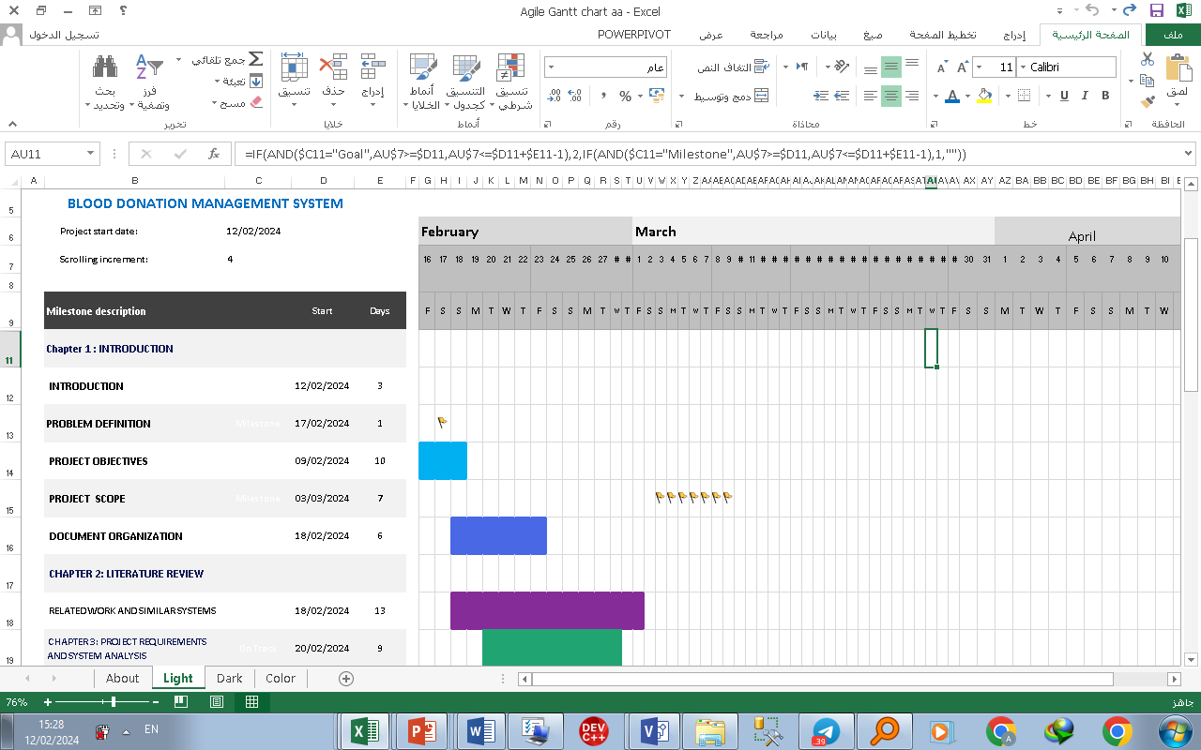

Figure ‑ Project Timeline

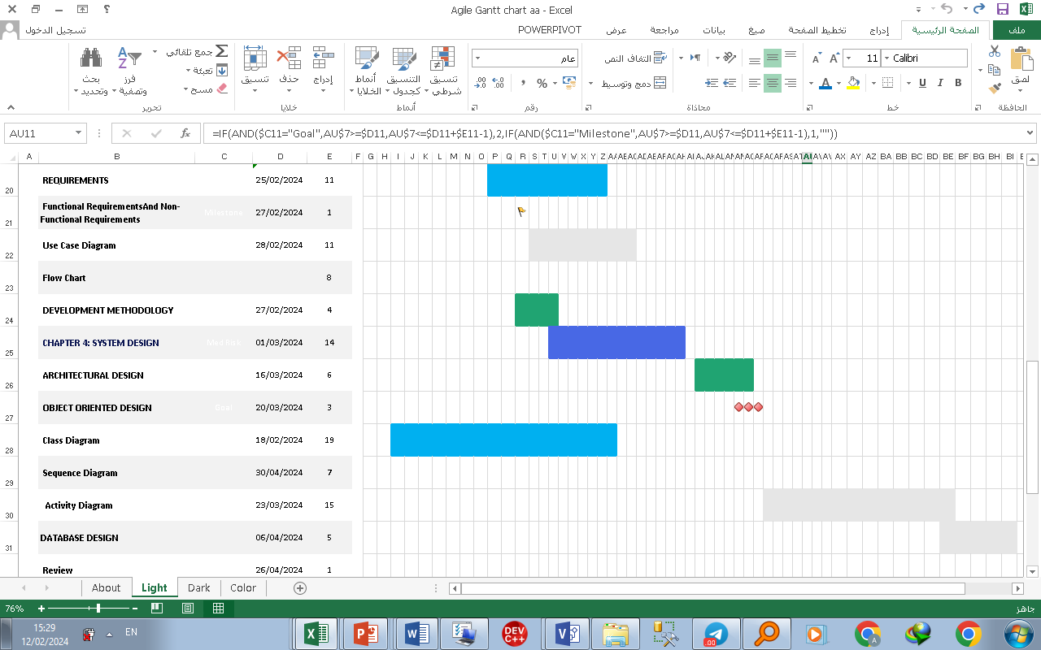

## Document Organization

1.6 Document Organization

This project report has been organized into six comprehensive chapters that guide the reader through the development of our Blood Donation Management System. The content of each chapter is outlined as follows:

**In Chapter 1**: Introduction, we provide an overview of the project, beginning with an introduction to the concept of blood donation and its importance. We then define the problem statement, highlighting the challenges faced in the current blood donation landscape within our region. The project's key objectives are clearly outlined, along with the defined scope and timeline for completion. The chapter concludes by outlining the organization of the document.

**Chapter 2**: Literature Review presents a detailed review of existing literature and similar systems related to blood donation management. We examine the features and functionalities of existing applications, such as the Wateen and Ihsan platforms, to identify best practices and inform the design of our proposed system. This exercise helped us gain valuable insights into the current state of blood donation management solutions.

**In Chapter 3**: Project Requirements and System Analysis, we delve into the specific requirements of our Blood Donation Management System, categorizing them as functional and non-functional. The system design is then illustrated through use case diagrams and flow charts, providing a high-level understanding of the application's key processes and user interactions. Additionally, we justify the selection of the waterfall development methodology for this project, as it aligns with the structured nature of our objectives.

**Chapter 4:** System Design focuses on the detailed design of our Blood Donation Management System. It covers the architectural design, object-oriented design principles, database schema, and user interface layouts. Data flow diagrams and an entity relationship diagram are presented to showcase the system's data structures and information flows, ensuring a robust and scalable foundation.

The implementation of our project is documented in **Chapter 5**: Implementation and Results. This chapter outlines the tools and technologies we employed, the specific implementation approach using Html, php, css, and the testing strategies used to ensure the system's functionality and reliability. By leveraging the flexibility and extensive plugin ecosystem of Html, php, css, we were able to develop a feature-rich system that meets the project's goals.

Finally, **Chapter 6**: Conclusion and Future Work summarizes the key insights and achievements of our project. It also discusses the limitations encountered and suggests potential areas for future enhancements and improvements to the Blood Donation Management System, ensuring its continued relevance and effectiveness in serving the needs of our community.

Each chapter concludes with a summary that recaps the main points covered and transitions to the next section of the report, maintaining a cohesive flow throughout the document.

# Chapter 2: Literature Review

## Introduction

This section introduces the literature review and background study chapter, outlining its purpose and scope. It sets the stage for exploring existing research, theories, and knowledge relevant to the project's subject matter.

## Related work and Similar Systems

* **Wateen application:**

Figure ‑ Wateen application

About the project:

The Wateen application is the official application for blood donation in Saudi Arabia, and it is one of the qualitative initiatives launched in cooperation with the Ministry of Health. This application seeks to reduce the communication gap between donors and blood banks so that the blood donation process becomes easier, while it includes a database of more than (800) thousand.  Blood donor nationwide.

Objectives:

It aims to increase awareness about the importance of voluntary blood donation, and to work towards complete sufficiency, through voluntary donation within blood banks in the Kingdom.  The initiative also aims to spread awareness of the importance of blood donation within society, facilitate blood donation procedures through the (Wateen) application, fill the needs of blood banks within the Kingdom, and hold periodic donation campaigns, in addition to improving the donor experience on a continuous and permanent basis.

* **lhsan platform:**



Figure ‑ lhsan platform

About Ihsan:

  Ihsan is a Saudi national platform for charitable work that works to develop advanced technical solutions and invest in data and artificial intelligence with the aim of maximizing the impact and sustainability of charitable and development projects and services, through effective partnerships between the government, private and non-profit sectors.

  Goals:

  1- PA Empowering the non-profit and development sector and expanding its imct.

  2- Promoting the values ​​of national belonging and humanitarian work among members of society.

  3- Integration with various government agencies and maximizing benefit from them.

  4- Activating the role of social responsibility in the private sector.

  5- Raising the level of reliability and transparency in charitable and development work.

  Project importance:

  Facilitating the donation process for those wishing to do good, through integration with other platforms, and informing them of the various donation areas available within the Kingdom of Saudi Arabia in one place.

## Summary

The chapter concludes with a summary of key findings and insights gleaned from the literature review and background study.

# Chapter 3: Project Requirements and System Analysis

## Introduction

In this chapter, the proposed system is analyzed by a comprehensive discussion of feasibility study and functional and non-functional requirements. Further, it discusses the high-level architecture and the development methodology to be followed to achieve the project.

## Requirements

This section summarizes the functional and non-functional requirements of the projects’ deliverables. Depending on the nature of the requirements, they will be categorised in to two categories, functional and non-functional.

### Functional Requirements

1. User Registration: Allow users to register as donors, recipients, or administrators.

2. Donor Search: Enable recipients to search for blood donors based on blood type, location, and availability.

3. Appointment Scheduling: Allow recipients to schedule appointments with donors for blood donations.

4. Donation History: Maintain a record of donors' donation history for tracking purposes.

5. Blood Inventory Management: Manage and update the inventory of available blood units, including expiration dates and quantities.

6. Notification System: Notify donors about upcoming appointments, urgent blood needs, or donation events.

7. Feedback Mechanism: Provide a way for recipients to provide feedback on their donation experience.

8. Administrator Dashboard: Allow administrators to manage user accounts, oversee donation activities, and generate reports.

### Non-Functional Requirements

1. Usability: Ensure the website is user-friendly and accessible to all users, including those with disabilities.

2. Performance: Ensure the system can handle multiple concurrent users and maintain responsiveness during peak usage times.

3. Security: Implement measures to protect user data, including encryption of sensitive information and secure login mechanisms.

4. Reliability: Ensure the system is reliable and available 24/7, with minimal downtime for maintenance or upgrades.

5. Scalability: Design the system to accommodate growth in users and data without significant performance degradation.

6. Compatibility: Ensure compatibility with a range of web browsers and devices to reach a broad audience.

7. Regulatory Compliance: Ensure compliance with relevant regulations and standards for handling sensitive medical data and blood products.

8. Disaster Recovery: Implement backup and recovery procedures to mitigate the risk of data loss in case of system failure or disaster.

## System Design

This section highlights the design of the proposed system by illustrating the application flow via flowchart and use case diagram.

### Use Case Diagram

**System Overview:**

- System Name: Blood Donation Management System.

- Purpose: To facilitate the management of blood donation activities, including donor registration, blood request handling, and inventory management

**Actors and Their Use Cases:**

The diagram includes four main actors, each with specific interactions with the system:

**1. Donor:**

- Register/Sign Up: Allows donors to create an account in the system.

  - Log In: Enables donors to access their account.

  - Update Profile: Donors can update their personal information.

  - View Donation History: Donors can view their past donation activities.

- Find Donation Events: Enables donors to locate upcoming donatio events.

- Receive Notifications: Donors receive updates and reminders.

- Donate Blood: Functionality to record the donation process.

- Feedback: Donors can provide feedback about their experience.

**2. Recipient:**

- Request Blood: Recipients can request blood for their needs.

  - Track Request: Allows tracking the status of their blood request.

  - Receive Blood: Process through which recipients receive the requested blood.

**3. Healthcare Professional:**

- Verify Donors: Healthcare professionals can verify donor eligibility.

  - Manage Blood Inventory: Includes functionalities for inventory tracking and management.

  - Approve/Reject Requests: They have the authority to approve or reject blood requests.

  - Coordinate Donations: Facilitate and coordinate the donation process between donors and recipients.

**4. System Administrator:**

- Manage Users: Administrators can manage user accounts and profiles.

  - Update System: Responsible for system updates and maintenance.

  - Monitor and Respond to Feedback: Administrators monitor user feedback and respond accordingly.

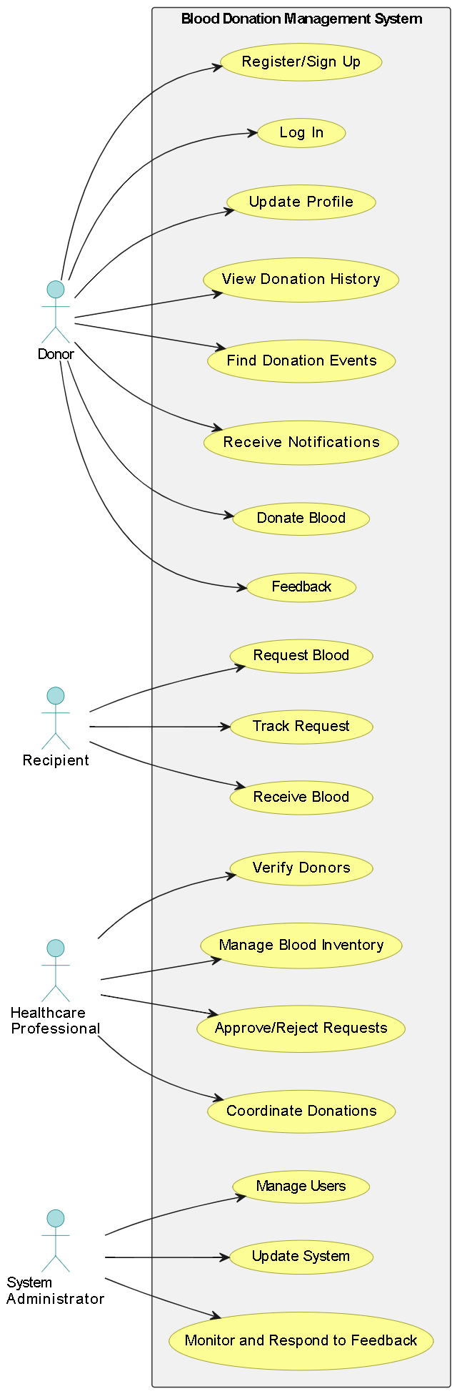

Figure ‑ Use case Diagram

### Flow Chart

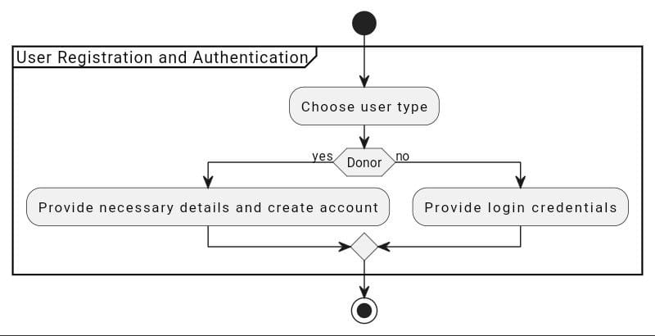

Figure ‑ Flow Chart 1

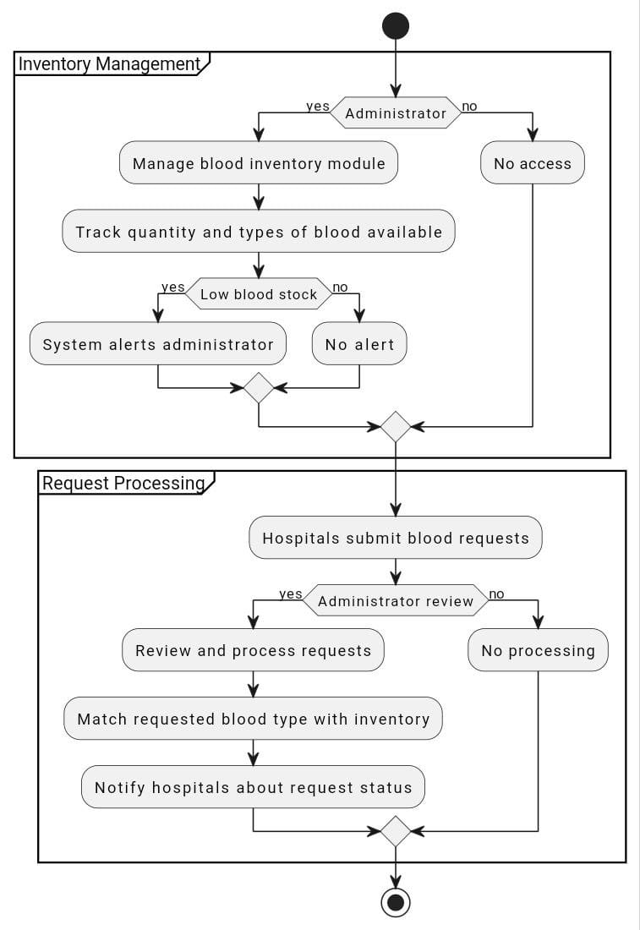

Figure ‑ Flow Chart 2

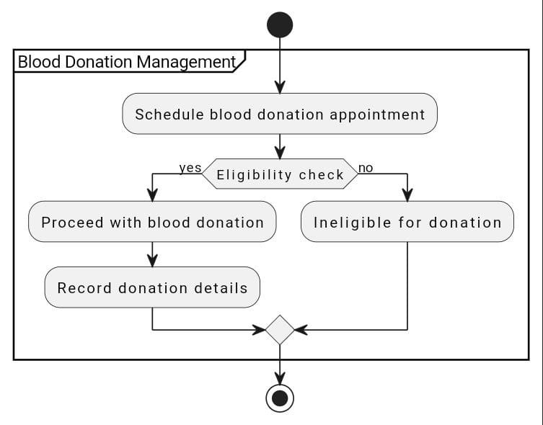

Figure ‑ Flow Chart 3

صورة تحتوي على نص, لقطة شاشة, رسم بياني, خط

تم إنشاء الوصف تلقائياً

Figure ‑ Flow Chart 4

## Development Methodology

**Waterfall Methodology**

We as a project will use this type because This model provides a structured approach through discrete phases that are easy to understand and interpret, provides easily identifiable milestones in the development process, and can be suitable for projects where scope requirements are fixed.

The Waterfall model is a sequential design process typically used in software development processes, in which workflow progresses in steady pieces flowing from top to bottom (like a waterfall) through stages: initiation, analysis, design, construction, testing, production, implementation, and maintenance. And it is by dividing the project activities into linear successive stages, where each stage depends on the outputs of the previous stage and corresponds to a specialization in tasks. The approach is typical of certain areas of engineering design. In software development, it tends to be among the least iterative and flexible approaches, as progress flows in largely one direction ("down" like a waterfall) through the phases of conceptualization, initiation, analysis, design, build, testing, deployment.

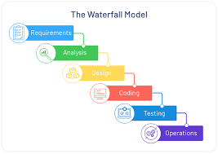

Figure ‑ Waterfall Methodology

## Summary

The chapter concludes with a summary of the project requirements and system analysis, encapsulating key insights and decisions that inform the subsequent phases of system development.

# Chapter 4: System Design

## Introduction

This chapter presents the system design of our **Blood Donation Management System**, developed to bridge the gap between blood donors and recipients through a web-based platform created on Html, php, css. Our design approach covered the main structural and functional aspects, including the system’s high-level architecture, object-oriented principles, database design, and user interface layout. Each design decision was made with the end user in mind, aiming for a responsive, accessible, and intuitive experience that supports efficient blood donation coordination.

#### 4.1.2DATA FLOW DLGRAMS (DFD)

**- Data Flow Diagram - Context Diagram**

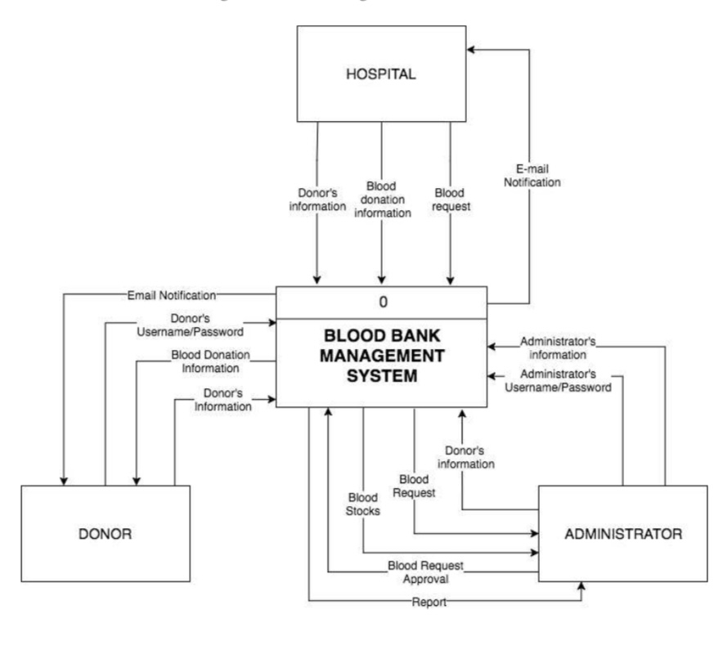

Figure ‑ Data Flow Diagram - Context Diagram

* **Data Flow Diagram - Level 0**

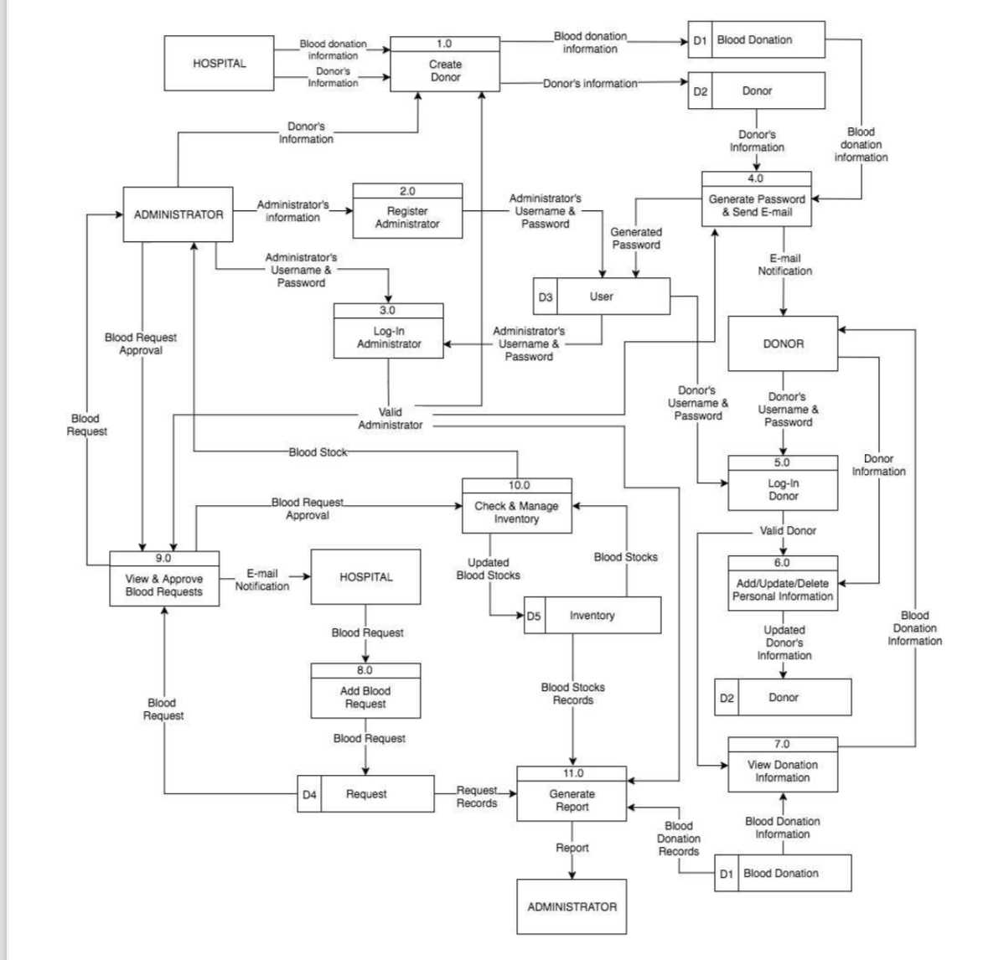

Figure ‑ -Data Flow Diagram - Level 0

## Architectural design

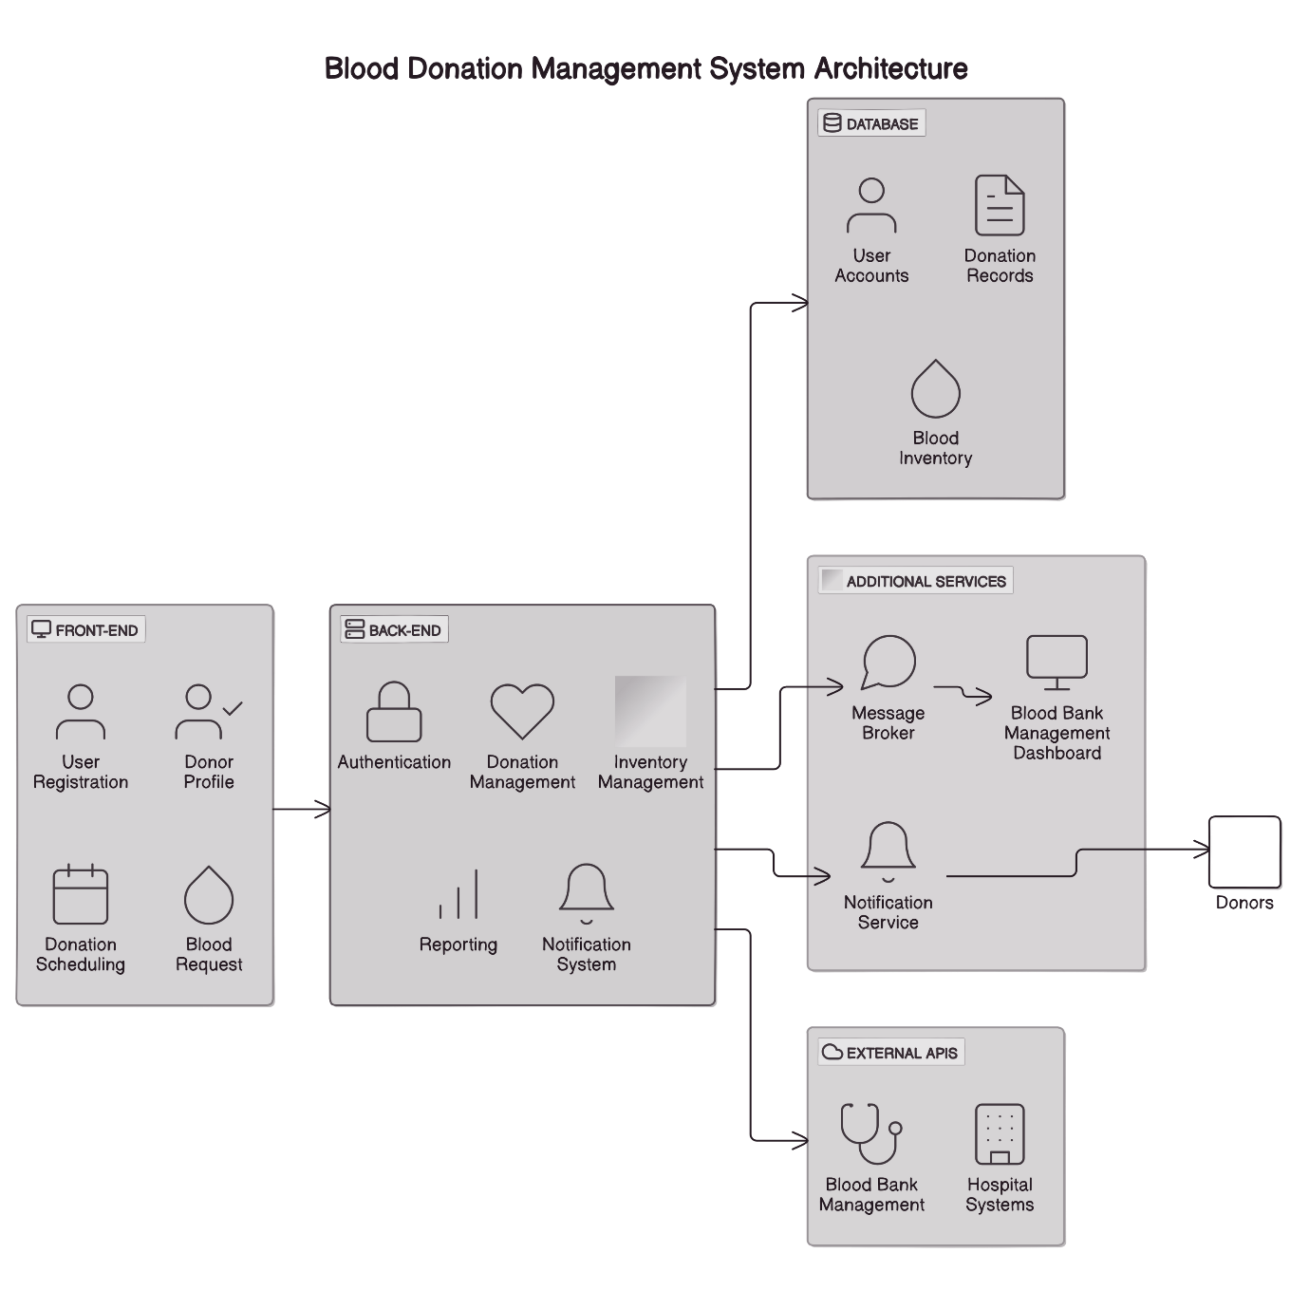

‎4.2‑1 System Architecture

## Object Oriented Design

### Class Diagram

The class diagram highlights the main classes and their relationships, which form the backbone of the **Blood Donation Management System**. Key classes include:

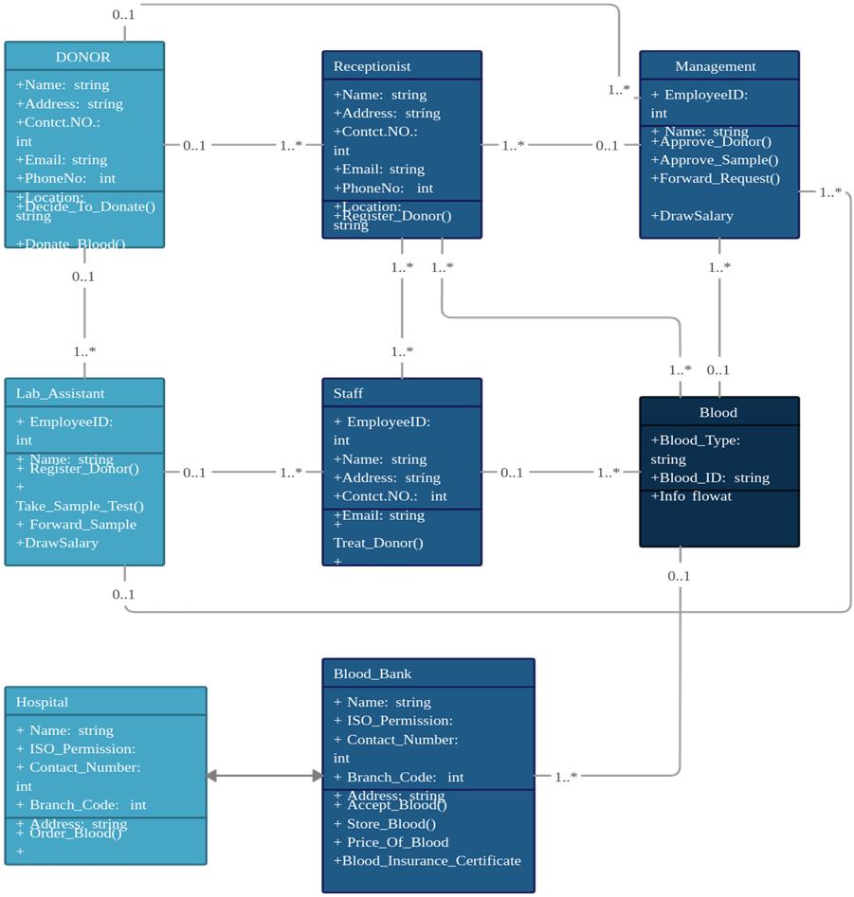

### Sequence Diagram

The sequence diagram visualizes the step-by-step interactions between objects over time, capturing essential processes such as blood requests and appointment scheduling.

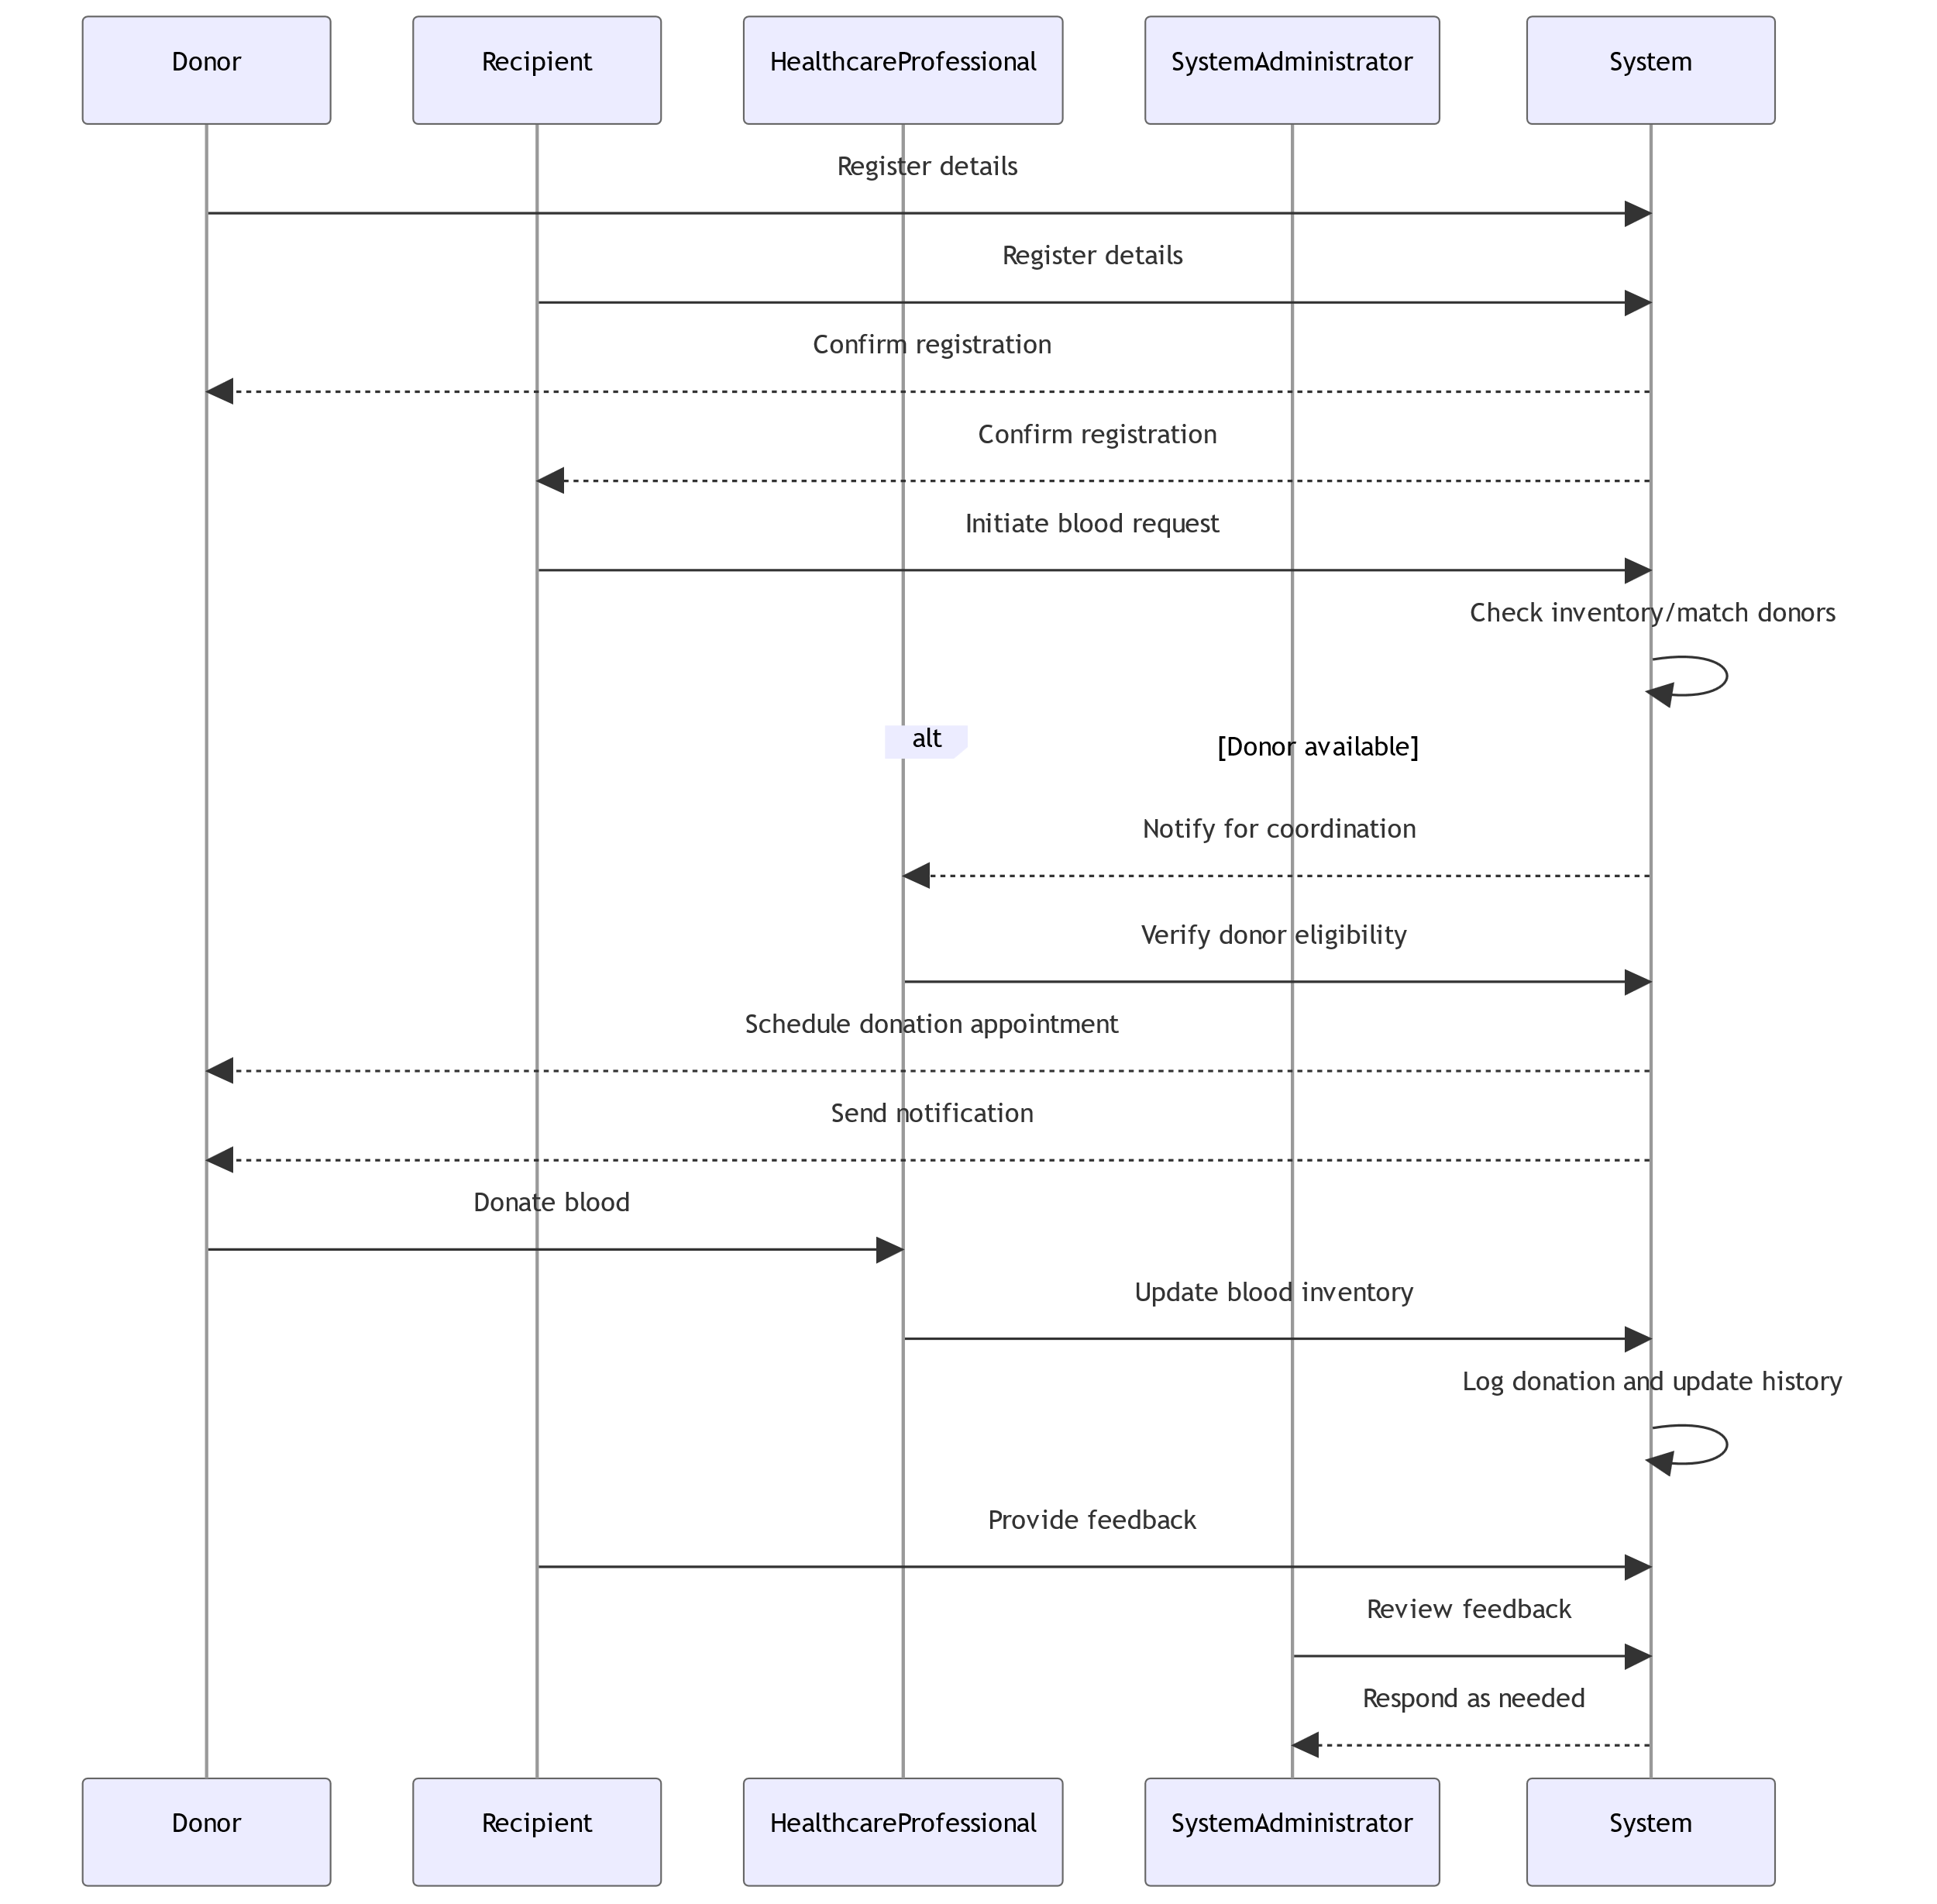

‎4.3‑1 sequence diagram

### Activity Diagram

The activity diagram represents the logical flow of the system, depicting decision points and pathways for users. Major workflows include:

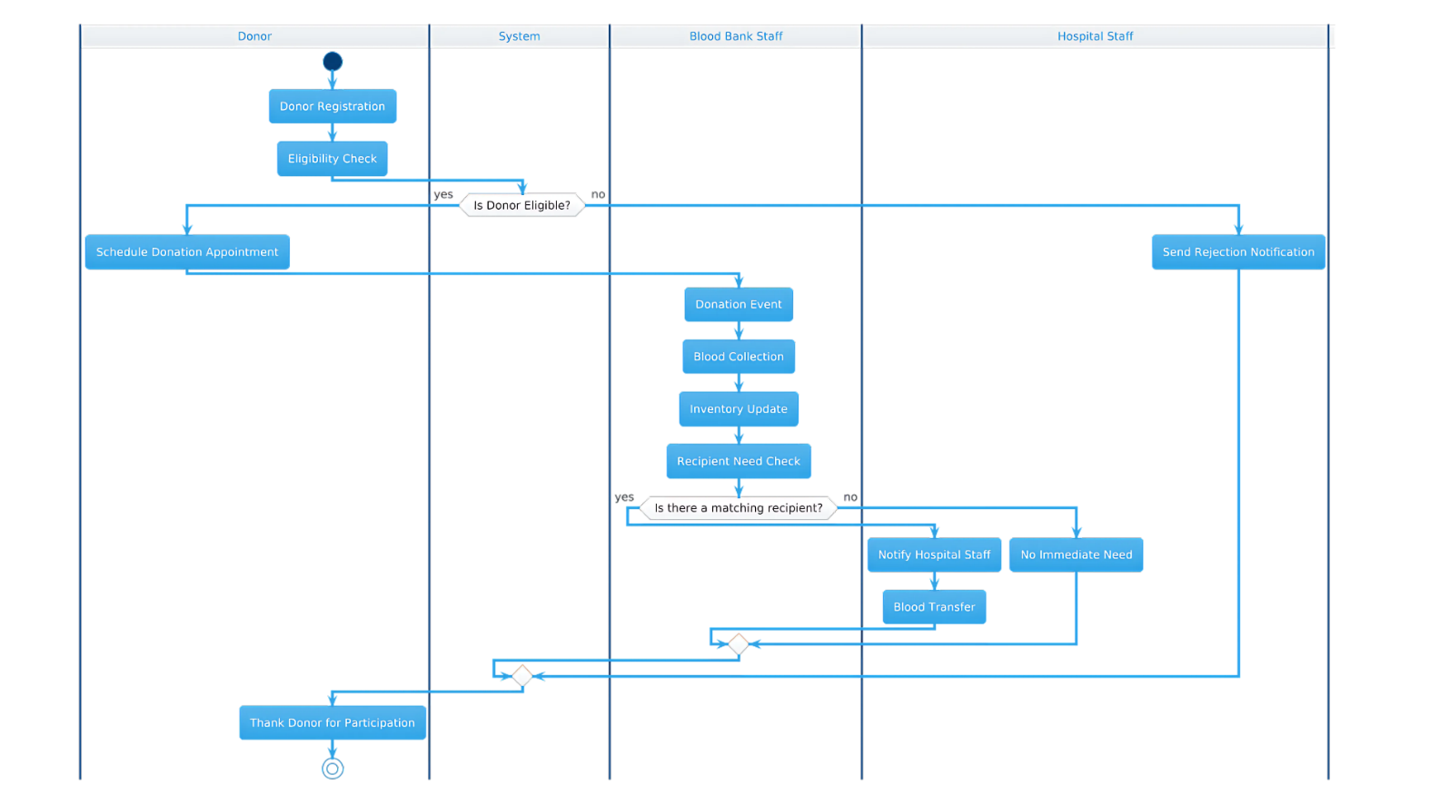

‎4.3‑2 Activity diagram

## Database Design

The database design is fundamental to the **Blood Donation Management System**, built using MySQL to securely store and retrieve user data, blood inventory records, and appointment details.

**Table: donor_details**

|  |  |  |
| --- | --- | --- |
| Attribute | Type | Role |
| donor_id | **number** | **PK** |
| Name | **varchar** |  |
| Address | **varchar** |  |
| Contact_NO | **varchar** |  |
| Email | **varchar** |  |
| donor_age | **number** |  |
| donor_gender | **varchar** |  |
| Blood_Group | **varchar** | **FK** |

‑1 Table: donor_details

**Table: users**

|  |  |  |
| --- | --- | --- |
| Attribute | Type | Role |
| user_id | **number** | **PK** |
| user_mobile | **number** |  |
| user_email | **varchar** |  |
| user_password | **varchar** |  |

‑2 Table: users

**Table: admin_info**

|  |  |  |
| --- | --- | --- |
| Attribute | Type | Role |
| admin_id | **number** | **PK** |
| admin_name | **varchar** |  |
| admin_username | **varchar** |  |
| admin_password | **varchar** |  |

‑3 Table: admin_info

**Table: pages**

|  |  |  |
| --- | --- | --- |
| Attribute | Type | Role |
| page_id | **number** | **PK** |
| page_name | **varchar** |  |
| page_type | **varchar** |  |
| Email | **varchar** |  |
| page_data | **longtext** |  |

‑4 Table: pages

**Table: BLOOD**

|  |  |  |
| --- | --- | --- |
| Attribute | Type | Role |
| Blood_ID | **number** | **PK** |
| blood_group | **varchar** |  |

‑5 Table: BLOOD

**Table: contact_info**

|  |  |  |
| --- | --- | --- |
| Attribute | Type | Role |
| contact_id | **number** | **PK** |
| contact_address | **varchar** |  |
| contact_mail | **varchar** |  |
| contact_phone | **varchar** |  |

‑6 Table: contact_info

**Table: contact_query**

|  |  |  |
| --- | --- | --- |
| Attribute | Type | Role |
| query_id | **number** | **PK** |
| query_name | **varchar** |  |
| query_mail | **varchar** |  |
| query_number | **char** |  |
| query_message | **longtext** |  |
| query_date | **timestamp** |  |
| query_status | **int** |  |

‎4.4‑7 Table: contact_query

## User Interface Design

### Home page user interface design

The project details user interface design, including layout, navigation, and visual elements of the system.

Our website home page is the main gateway for visitors, attracting their attention when they arrive. This page features a design that balances simplicity and clarity, and prominently features our “HAYAT” logo. The top menu includes basic links such as: “Home”, “About Us”, “Why Donate Blood”, “Become A Donor”, “Need Blood”, “Contact Us”,“Log In”, ​​and “Registration”.

Home page

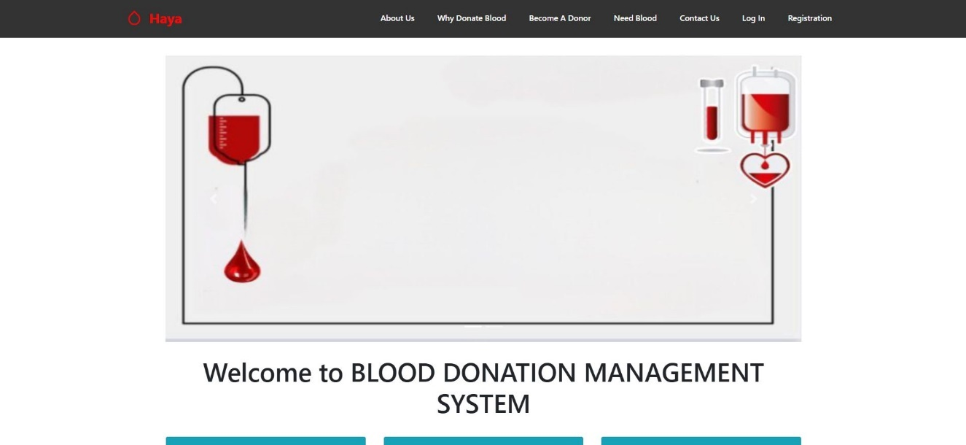

Figure Home page user interface design

The homepage is crafted to enhance user experience by providing easy access to information and encouraging active participation in supporting the humanitarian cause.

#### User interface design of LOGIN

This page showcases the design of the login interface for the "HAYAT" website. It allows users to log in using their email and password, along with links for registration The design is straightforward and user-friendly, ensuring a smooth user experience.

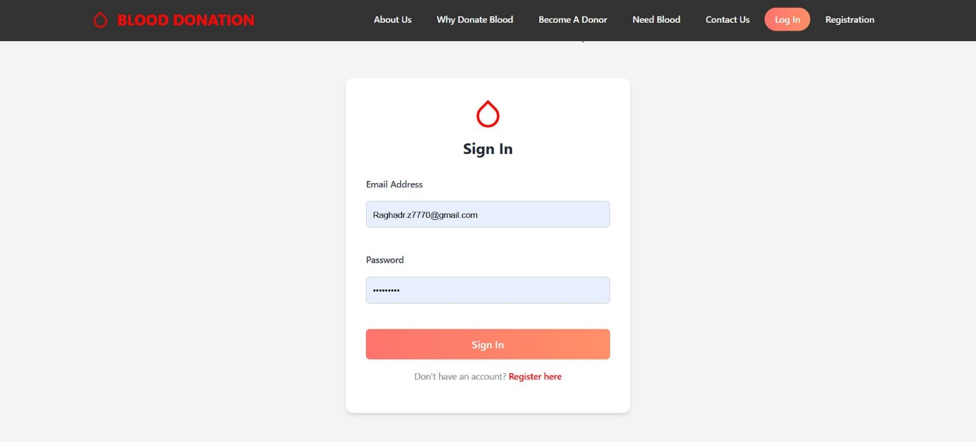

Figure User interface design of LOGIN

#### User interface design of CREATE AN ACCOUNT

This page displays the design of the account creation interface for the "HAYAT" website. It enables new users to input the required information, such as name, age, boold group, address, email, and password, to create a new account. The design is comfortable and simplified to facilitate easy account creation

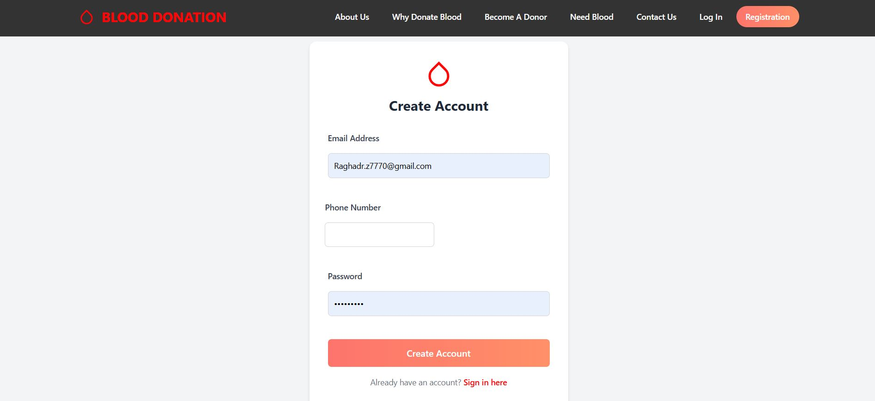

Figure User interface design of CREATE AN ACCOUNT

## Summary

The system design of the HAYAT Management System integrates PHP , HTML , CSS flexibility with object-oriented principles, a well-structured database, and user-centered design. Each design element—architecture, object classes, data structures, and interface layouts—was carefully developed to ensure the platform is effective, user-friendly, and scalable. Our design approach creates a strong foundation for the system, supporting the project's goal to enhance blood donation accessibility and coordination.

1. **Chapter 5: Implementation and Results**
   1. **Introduction**

This chapter documents the practical steps we took to build the **Hayat Management System** using Html, php, css. It covers the tools and technologies that supported our development, the Html, php, css-specific implementation approach we adopted, and the testing phases we executed to ensure functionality and reliability. Each stage in this chapter highlights our focused approach to creating a responsive and secure system that effectively meets the project’s goals of connecting blood donors and recipients.

* 1. **Tools and Technologies used**

We chose Html, php, css as our primary platform due to its flexibility, user-friendly interface, and extensive plugin ecosystem, which allowed us to build a feature-rich system without developing every feature from scratch. Below is an overview of the key tools and technologies we used:

* **languge** :
* **Html, php** : Html, php served as the core framework for our project, allowing us to quickly set up the structure and manage users effectively. We leveraged HTML, PHP and CSS to meet the specific needs of our blood donation system.
* **Design and Styling**:
  + **CSS Customization**: We customized the theme’s CSS to ensure that the site was visually appealing and fully responsive, allowing it to be easily accessible on various devices.
* **Testing Tools**:
  + **Onlain Domin**: We used Onlain Domin to test the integration points within Html, php, css, confirming that all data transactions worked as expected.
  1. **Implementation**

The implementation of the project.

* 1. **Testing Case**

Snapshots of a testing case.

* 1. **Results**

some photo of our web site:

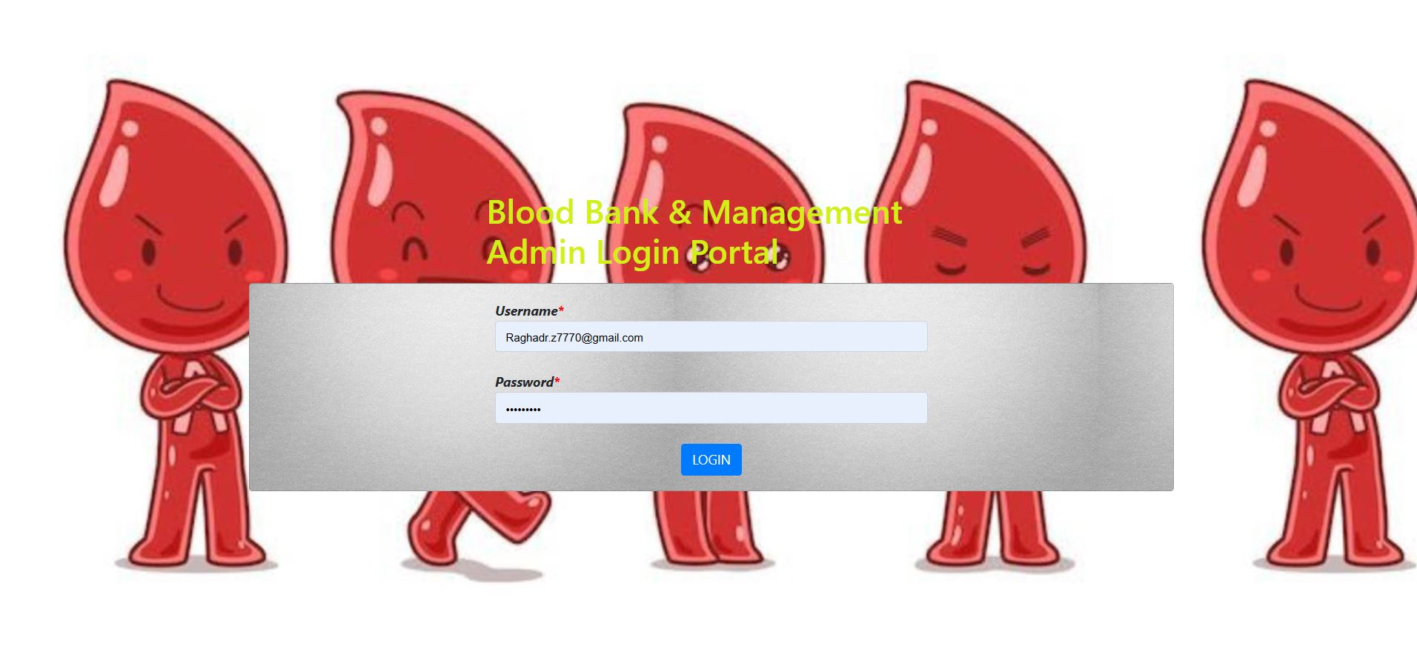

Figures 12 Admin Log In

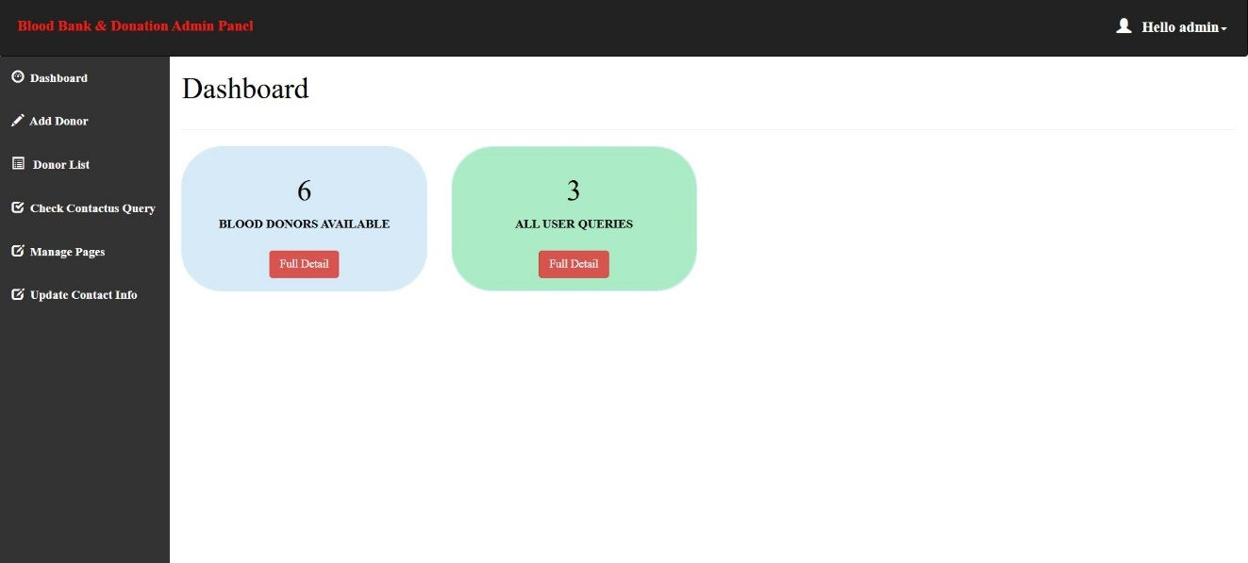

Figures 13 Admin Dashboard

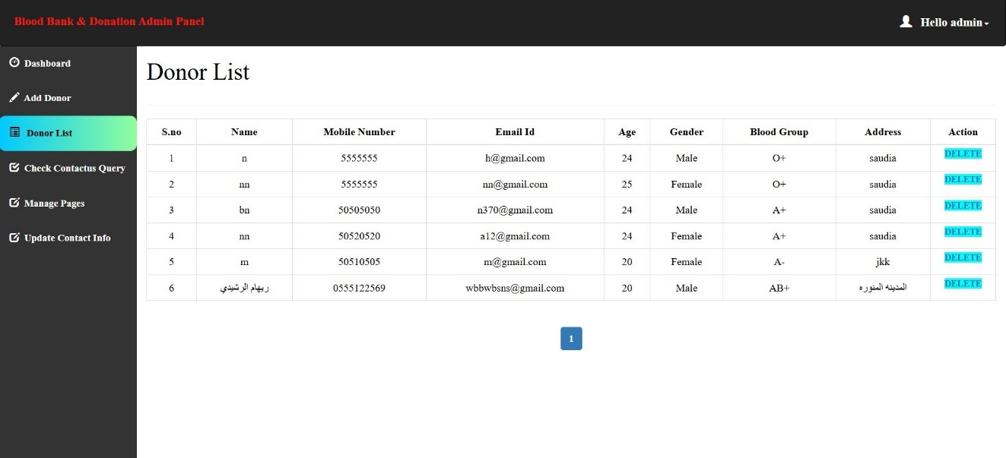

Figures 14 Admin Donor List

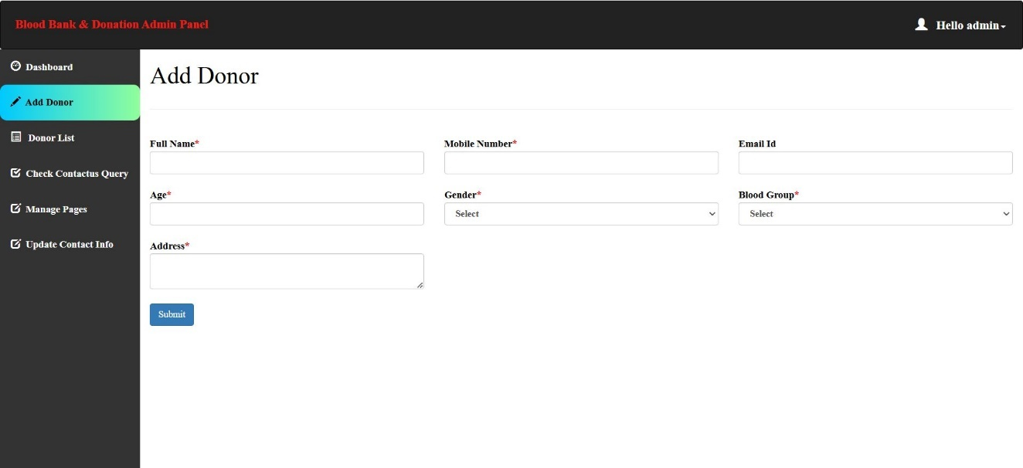

Figures 15 Add Donor

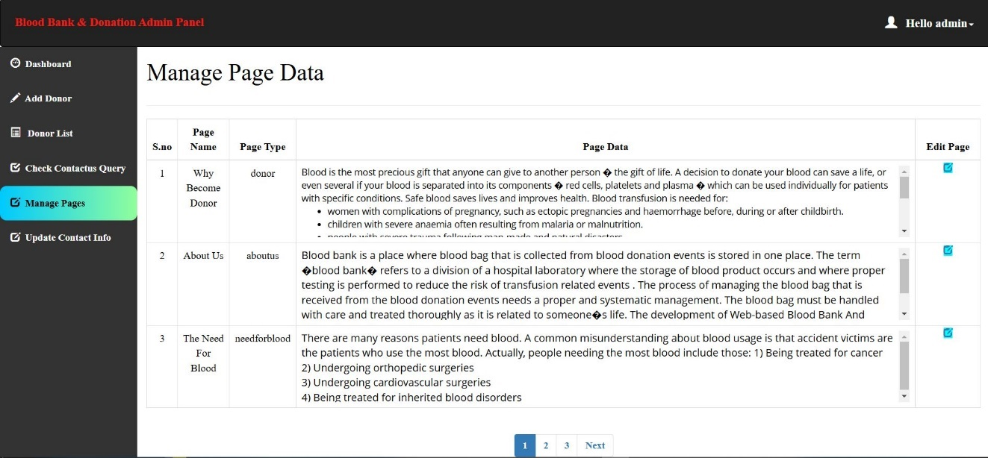

Figures 16 Admin Manage Page Data

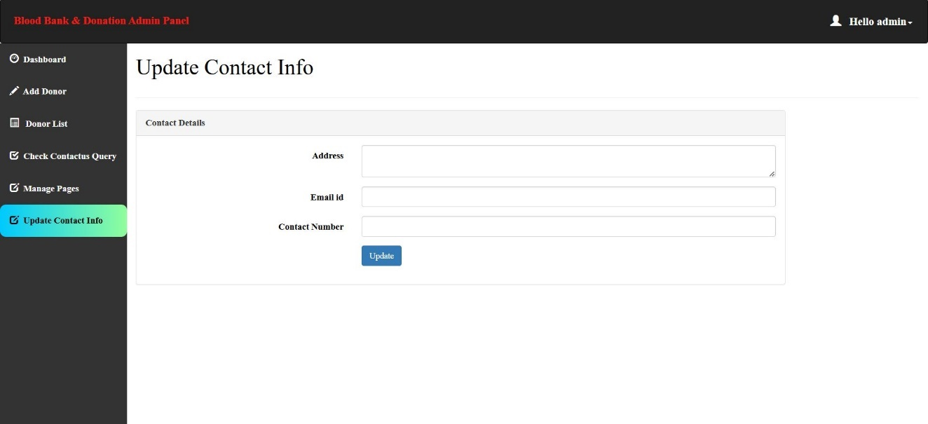

Figure 17 admin Update Contact Info

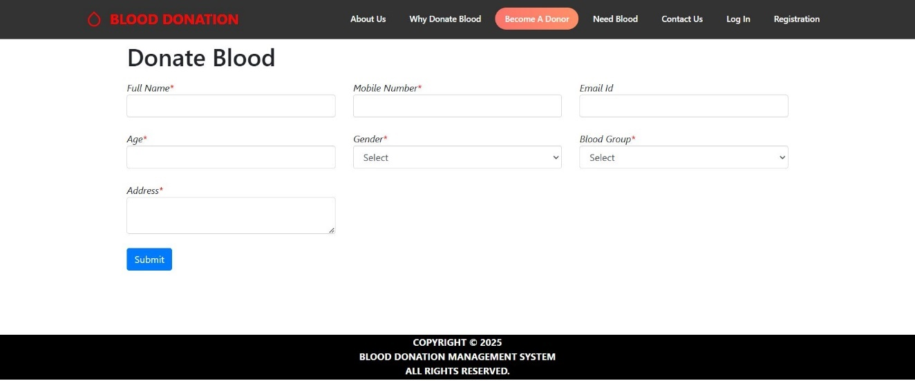

Figures 18 User Donate Blood

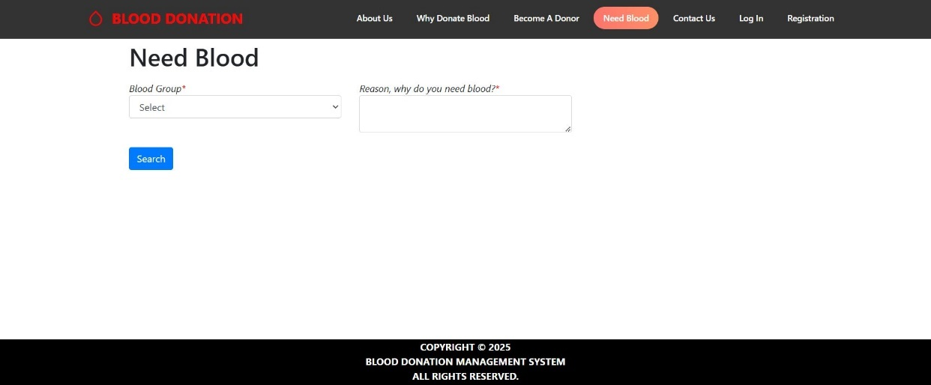

Figures 19 User Need Blood

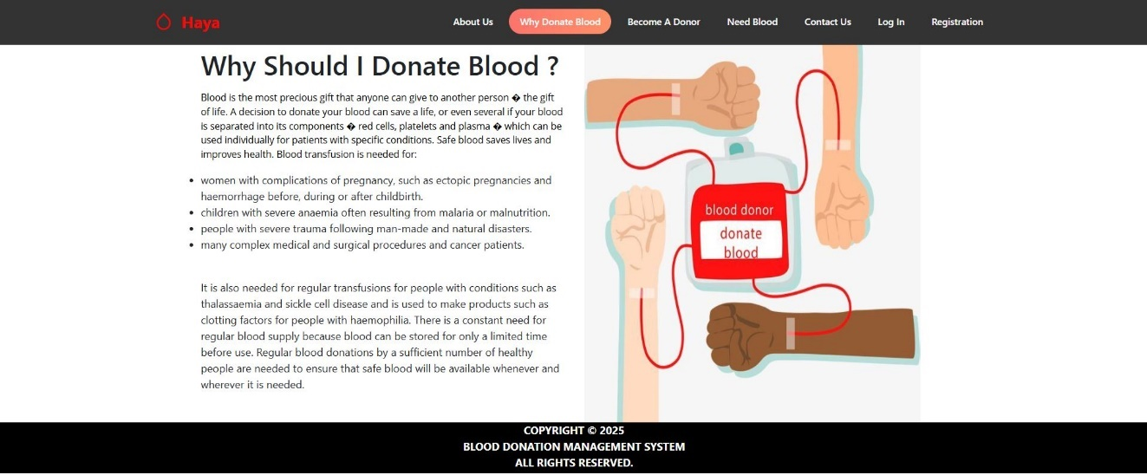

Figures 20 User Why Should I Donate Blood

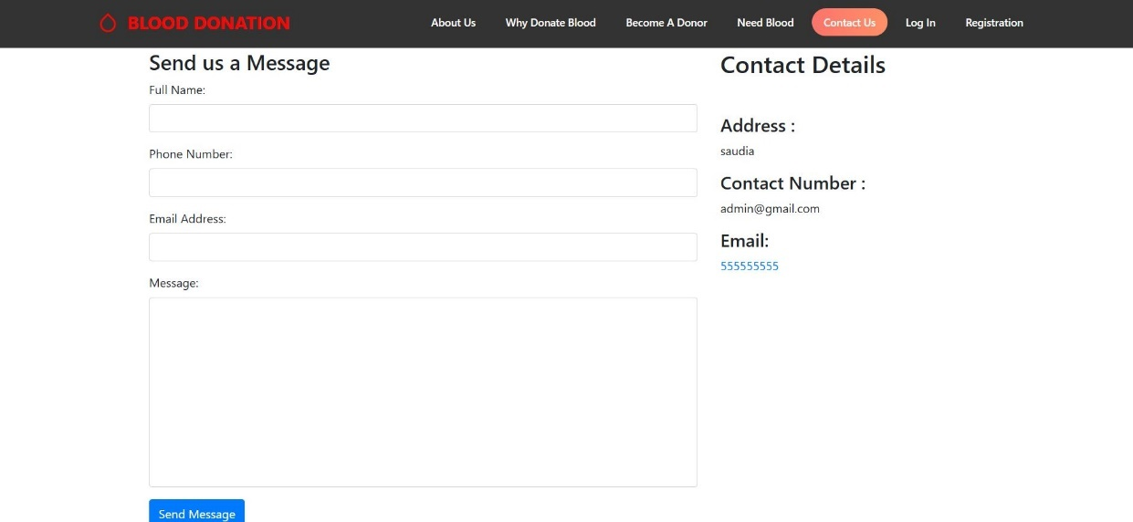

Figures 21 User Contact Us

1. **Chapter 6: Conclusion and Future Work**
   1. **Conclusion**

Our blood donation management system has succeeded in achieving its primary goal of creating an accessible platform to connect donors and recipients. Developed using Html, php and css, the system includes functions such as donor registration. During the project, we gained valuable insights into the importance of designing user-friendly interfaces to effectively engage both the public and administrators. This project reinforced the importance of a structured development approach, creating a scalable platform that addresses blood shortages through enhanced community engagement.

* 1. **Limitations**

Throughout the project, we encountered several constraints that limited the scope of our initial release:

**- Lack of Integration**: The system does not integrate with external healthcare databases, limiting comprehensive inventory management.

**- Mobile Accessibility**: Absence of a dedicated mobile app may hinder access for mobile users.

**- Limited Analytics:** Time constraints restricted the implementation of advanced analytics, providing only basic tracking.

* 1. **Future Work**

**- Database Integration**: Connect with healthcare databases for real-time inventory updates.

**- Mobile Application Development:** Create a dedicated app to enhance accessibility and engagement.

**- Advanced Analytics:** Implement features to forecast demand and optimize inventory.

**- User Engagement:** Add interactive features like donor rewards and educational resources.

**References**

The references section provides a detailed list of all sources cited or consulted during the project, adhering to a specified citation format for academic integrity.

[1] P. Likarish, E. Jung, D. Dunbar, T. E. Hansen, and J. P. Hourcade, "B-APT: Bayesian Anti-Phishing Toolbar," 2008 IEEE International Conference on Communications, 2008, pp. 1745-1749, doi: 10.1109/ICC.2008.335.

[2] Phishing website dataset available at https://www.kaggle.com/

[3] http://s3.amazonaws.com/alexa-static/top-1m.csv.zip

[4] . https://github.com/